Project Design Phase-2 Technology Stack (Architecture & Stack)

|  |  |
| --- | --- |
| Date | 15 October 2022 |
| Team ID | PNT2022TMID50986 |
| Project Name | Personal Assistant for Senior Who Are Self Reliant |
| Maximum Marks | 4 Marks |

Technical Architecture:

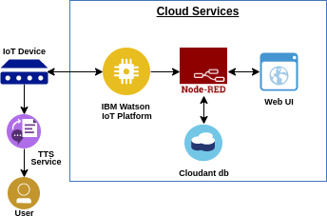

**Table-1: Components & Technologies:**

|  |  |  |  |
| --- | --- | --- | --- |
| **S.no** | **Component** | **Description** | **Technology** |
| 1. | User Interface | How user Interacts with application | JavaScript,HTML,CSS etc |
| 2. | Application Logic-1 | Logic for a Process in the application | Python |
| 3. | Application Logic-2 | Logic for a Process in the application | TTS service |
| 4. | Application Logic-3 | Logic for a Process in the application | IBM Watson Platform |
| 5. | Database | Data Type, Configurations etc. | Node-RED etc. |
| 6. | Cloud Database | Database Service on Cloud | IBM DB, IBM Cloudant etc. |
| 7. | File Storage | File storage Requirements | IBM Block Storage or Other Storage Service |
| 8. | External API-1 | Purpose of External API used in the application | Security API, etc. |
| 9. | External API-2 | Purpose of External API used in the application | Scalability API, etc. |
| 10. | Machine Learning Model | Purpose of Machine Learning Model | Object Recognition Model, etc. |
| 11. | Infrastructure | Application Deployment on Local System  / Cloud Local Server Configuration: Cloud Server Configuration | Local , Cloud Foundry, Kubernetes etc. |

**Table-2: Application Characteristics:**

|  |  |  |  |
| --- | --- | --- | --- |
| **S. No** | **Characteristics** | **Description** | **Technology** |
| 1. | Open-Source Frameworks | List the open-source frameworks used | Technology of Open source framework |
| 2. | Security Implementations | List all the security / access controls implemented, use of firewalls etc. | e. g. SHA-256, Encryptions, IAM Controls, OWASP etc. |
| 3. | Scalable Architecture | Justify the scalability of architecture (3  – tier, Micro-services) | Technology used |
| 4. | Availability | Justify the availability of applications (e. g. use of load balancers, distributed servers etc.) | Technology used |
| 5. | Performance | Design consideration for the performance of the application (number of requests per sec, use of Cache, use of CDN’s) etc. | Technology used |